# JS Advanced Final Exam

# Problem 1. Travel Agency

**Environment Specifics**

Please, be aware that every JS environment may **behave differently** when executing code. Certain things that work in the browser are not supported in **Node.js**, which is the environment used by **Judge**.

The following actions are **NOT** supported:

* **.forEach()** with **NodeList** (returned by **querySelector()** and **querySelectorAll()**)
* **.forEach()** with **HTMLCollection** (returned by **getElementsByClassName()** and **element.children**)
* Using the **spread-operator** (**...**) to convert a **NodeList** into an array
* **append()** in Judge (use only **appendChild()**)

If you want to perform these operations, you may use **Array.from()** to first convert the collection into an array.

**Use the provided skeleton to solve this problem.**

**Write the missing functionality** of this user interface. The functionality is divided in the following steps:

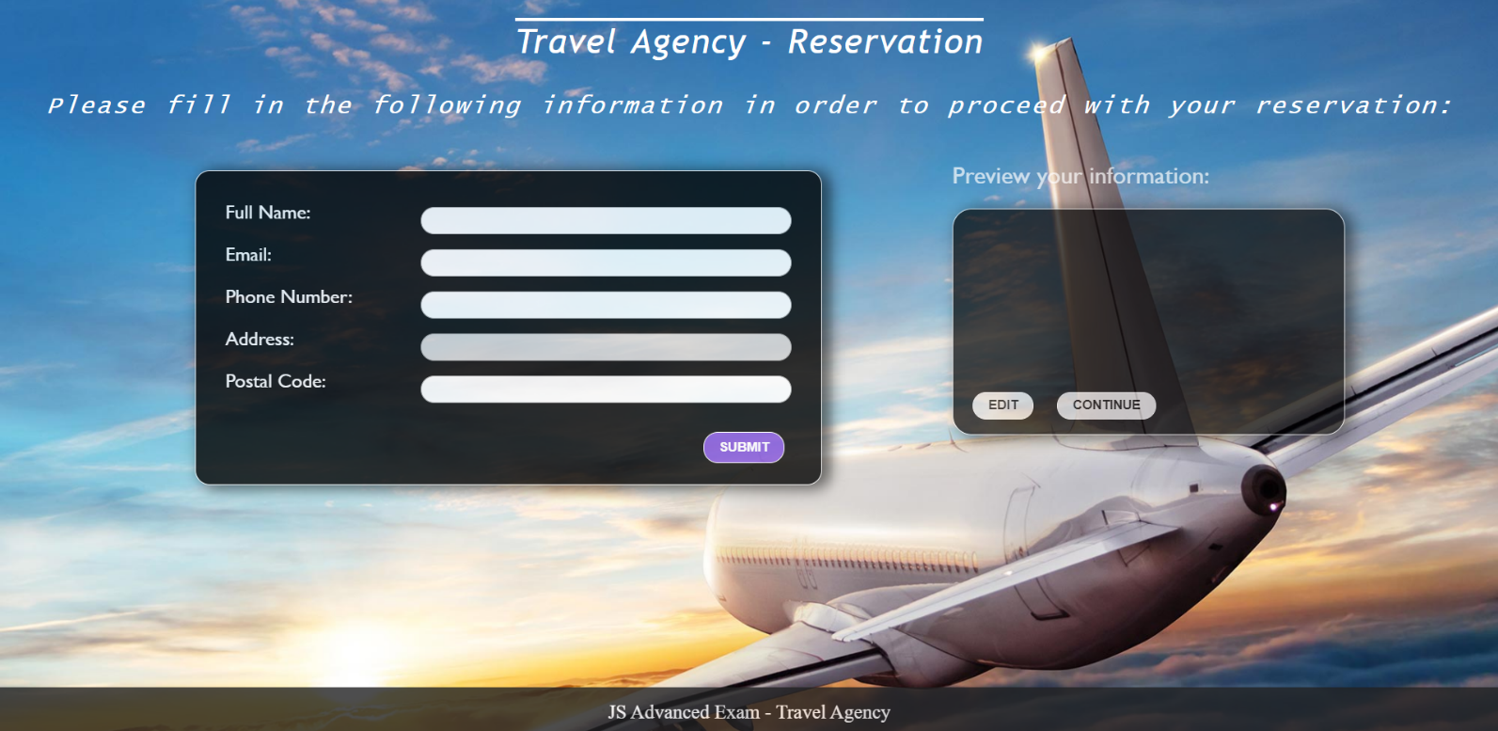

## ****Getting the user’s personal information****

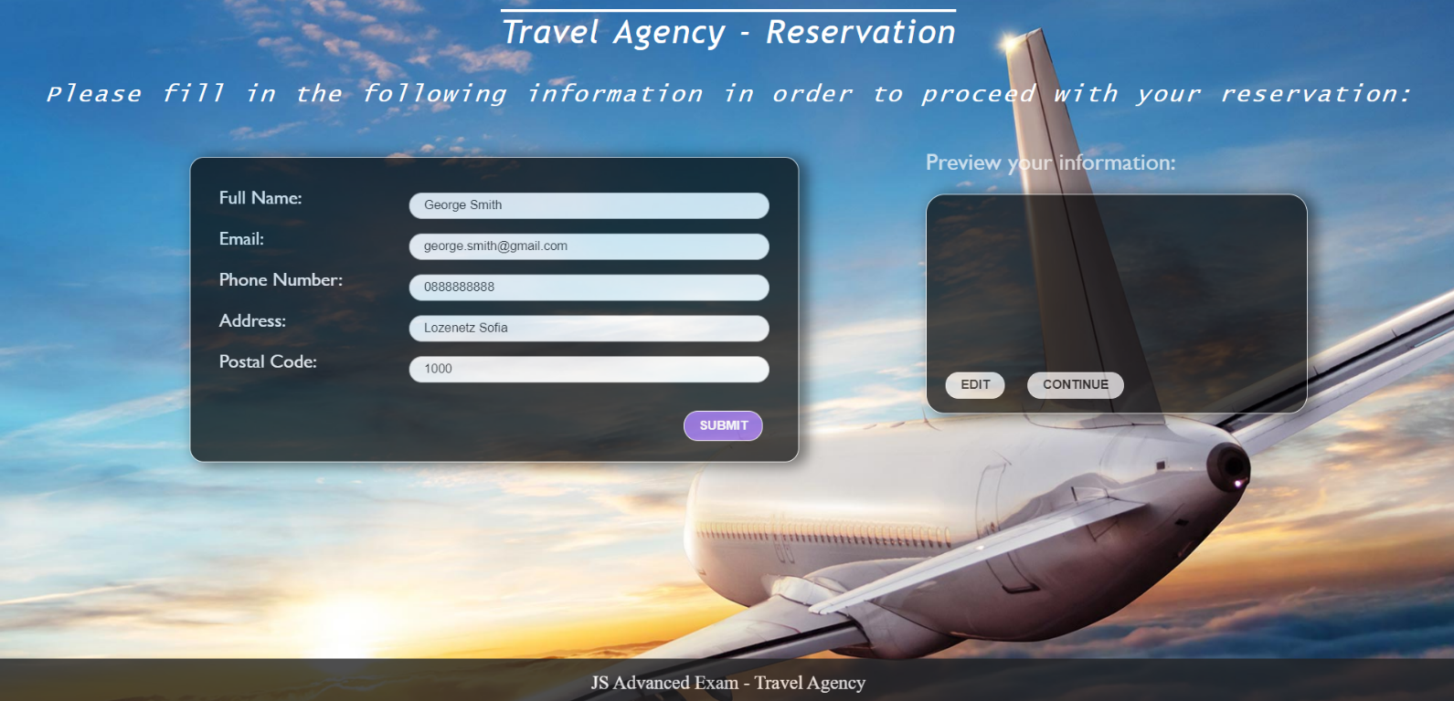

* On clicking the “Submit” button the information from the input fields is listed in the “preview” section. For each input field a **list item** is **added** to the “infoPreview” unordered list.
* The text format and order for each list item should be the same as on the second picture below.
* When the button is clicked, the input fields must be cleared and the “Submit” button must be **disabled**. At the same time the “Edit” button and the “Continue” button must be **enabled**.
* One can only submit information if the **“Full Name”** and **“Email**” input fields are **not empty**.

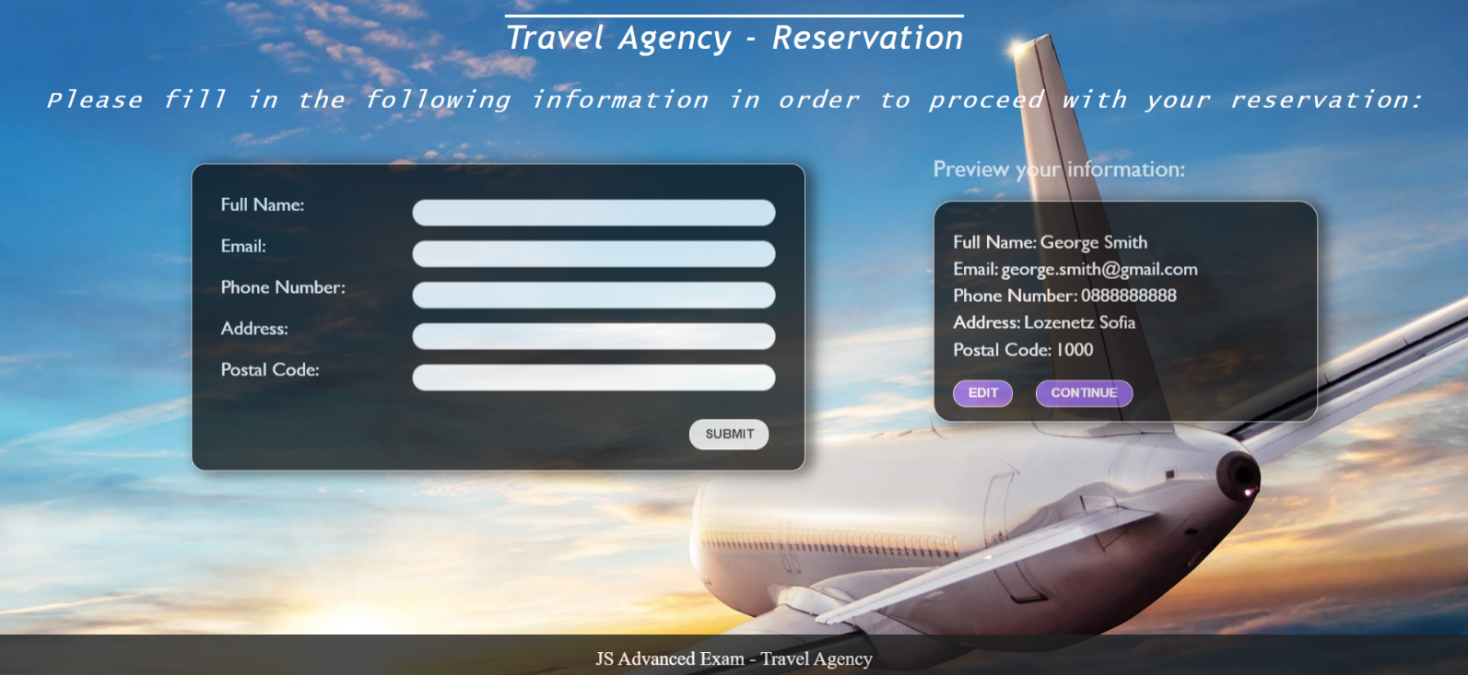

## ****Previewing the user’s personal information****

**This is an example for the preview section:**

, fi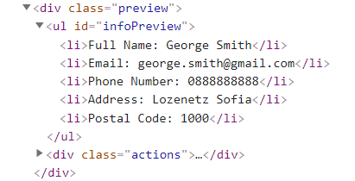

**The functionality here is the following:**

* **When the “**Edit” **button is clicked, all of the personal information of the user is loaded in the input fields from step I and both the** “Edit” **and** “Continue” **buttons are disabled while the** “Submit” **button is enabled again.**

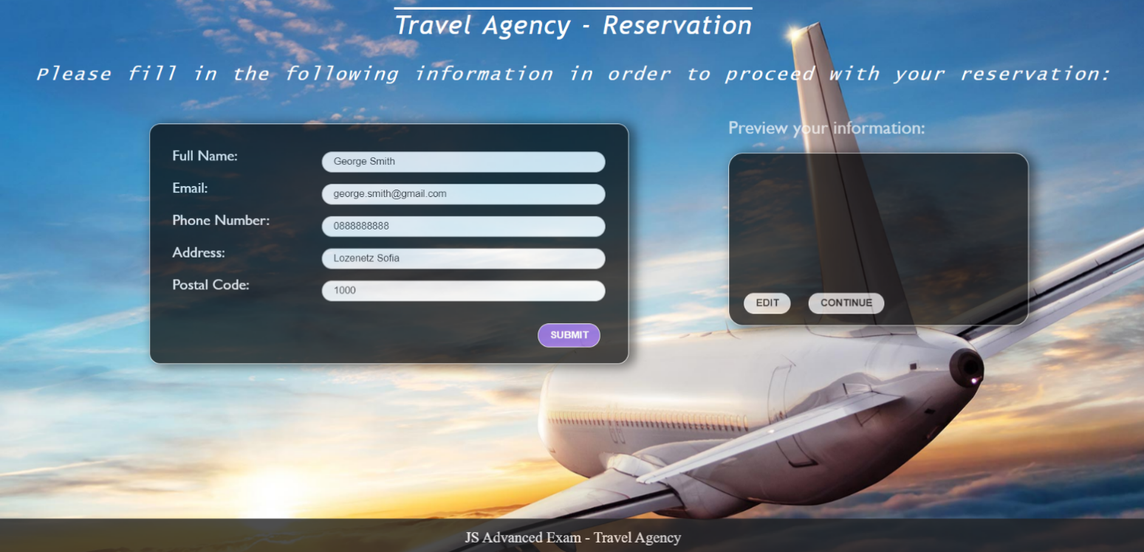

* **The list items must be removed from the** “infoPreview”**.**



* **When the** “Continue” **button is clicked,** **the reservation is completed. For you, this means removing everything inside of the** “block” **<div> and adding there only a <h3> tag: "Thank you for your reservation!" message:**



**This is everything your webpage must contain at this step:**

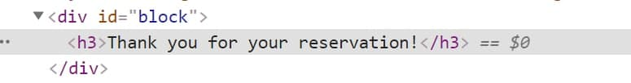

# Submission

Submit only yours **solution()** function.